Documentation | 
Auctions Table

Submitted To:  eProjects@aglsm.com |  Submitted By  - Aaman Ahmed  - Laiba  - Hafiz Muhammad Osaid Ahmed  Project Instructor:  (Miss Rabbia Anwar )  Curriculum Code :  (6740)  Batch Code:  1905G1

 AcKnowledgement

I have taken efforts in this project. However, it would not have been possible without the kind support and help of many individuals and organizations. I would like to extend my sincere thanks to all of them.
I am highly indebted to (Miss Rabbia Anwar) for her guidance and constant supervision as well as for providing necessary information regarding the project & also for her support in completing the project.
I would like to express my gratitude towards group Aptech computer education and my group members for their kind co-operation and encouragement which help me in completion of this project.



 Introduction
The thirst for learning, upgrading technical skills and applying the concepts in real life environment at a fast pace is what the industry demands from IT professionals today. However busy work schedules, far-flung locations, unavailability of convenient time-slots pose as major barriers when it comes to applying the concepts into realism. And hence the need to look out for alternative means of implementation in the form of laddered approach.

The above truly pose as constraints especially for our students too! With their busy schedules, it is indeed difficult for our students to keep up with the genuine and constant need for integrated application which can be seen live especially so in the field of IT education where technology can change on the spur of a moment. Well, technology does come to our rescue at such times!!

Keeping the above in mind and in tune with our constant endeavour to use Technology in our training model, we at Aptech have thought of revolutionizing the way our students learn and implement the concepts using tools themselves by providing a live and synchronous eProject learning environment!

 Problem statement
Auctions Table is an organization selling valuable items and goods through auctions. They have a vast experience of organizing auctions for past 25 years. Now with the client base expanding, they want to provide e-services for auctions. Hence, they want a website to be created with proper auction features.

Requirement Specification:

The Web site is to be created based on the following requirements.

- The home page must be designed with beautiful color combination with all the required links defined properly. Also all the section of the webpage must be in used to avoid the blank space.

- Home page should display all available items available for auction as a slide show.

- Menu should provide links to various auctions. Categorization of items should be done viz. Furniture, Paintings etc.

- On moving to any particular category, it should list various items available for auction.

- Clicking on any item should display the details of item along with the base price of the item.

- Menu should also provide link to completed auctions displaying the final price of product/item.

- About us, Contact Us, Disclaimer must be included.

- Creating an account facility can also be added.

- Dummy procedure for placing bid to be added.

- Sitemap must be added.

- Navigation of the project must be made smooth.

 Hardware/software requirements
Hardware

- A minimum computer system that will help you access all the tools in the courses is a Pentium 166 or better
- 64 Megabytes of RAM or better

Software

- Notepad/HTML editor
- Dreamweaver
- IE 5.0/ Netscape 6.0

Site map

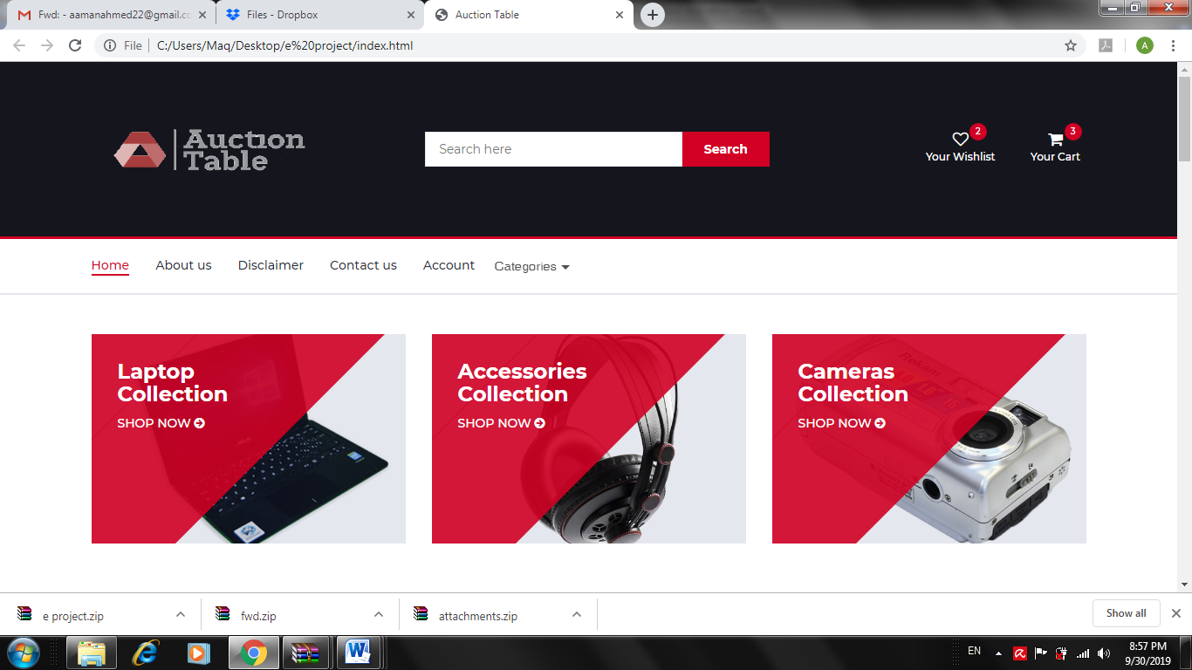

Categories
Home
Account
Contact us
Disclaimer
About us

Screen shots

Logo:



Search bar


Cart and Wishlist:


Navbar:



Shop grid:


Footer:

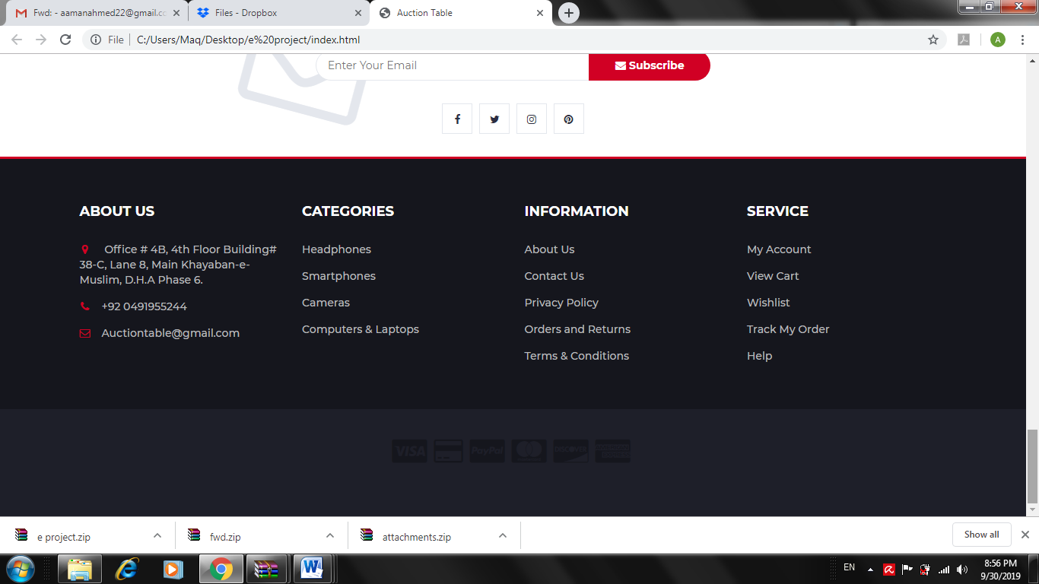

Our team:


Signin/Signup form:
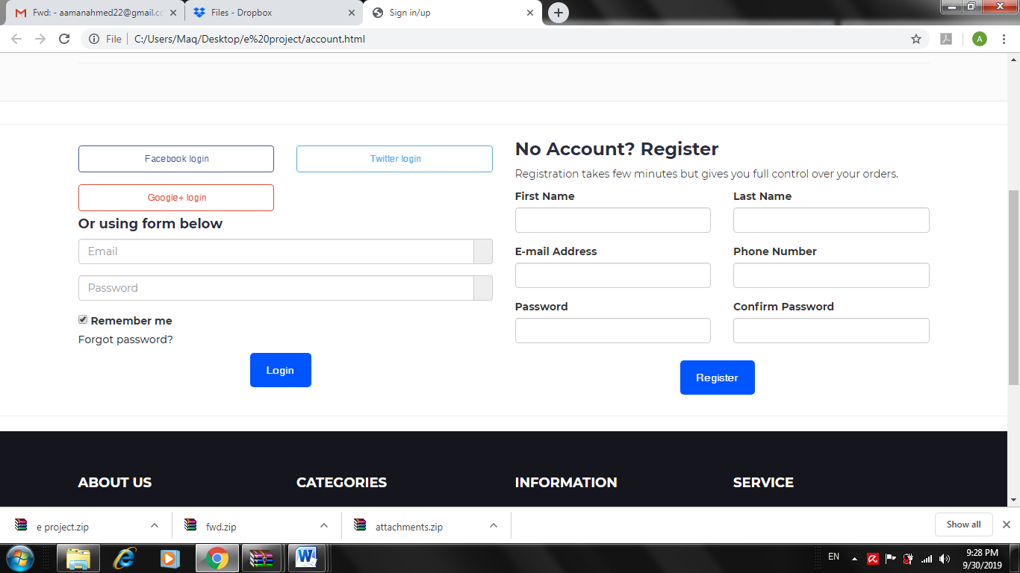

Checkout page:

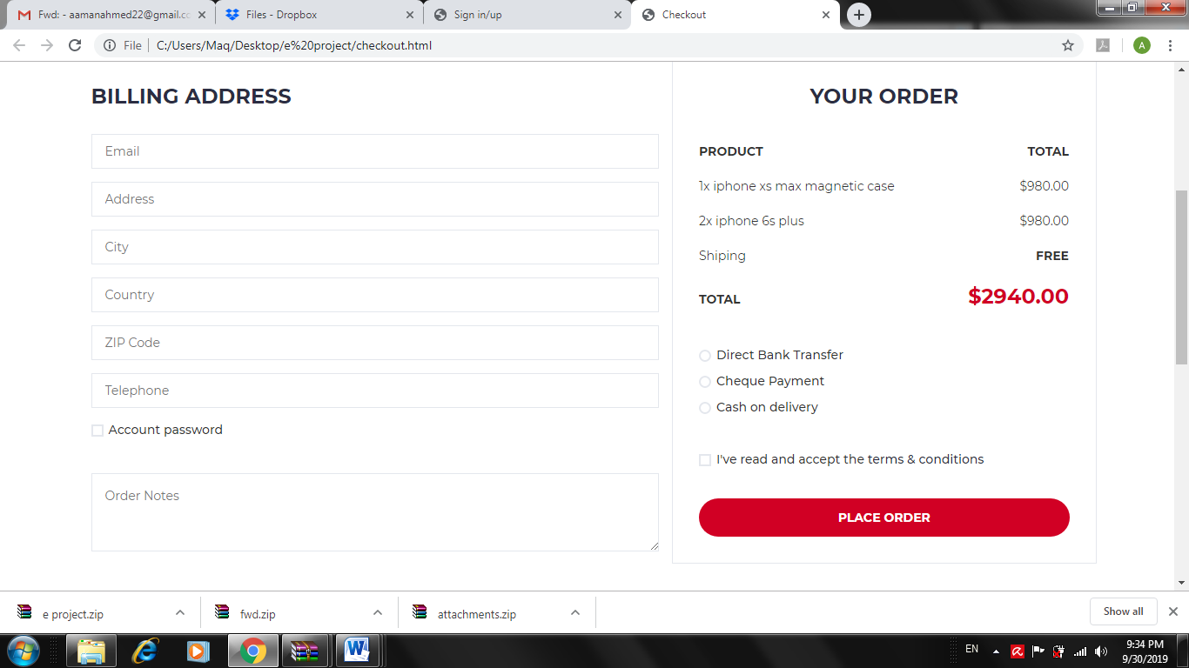
Contact us:

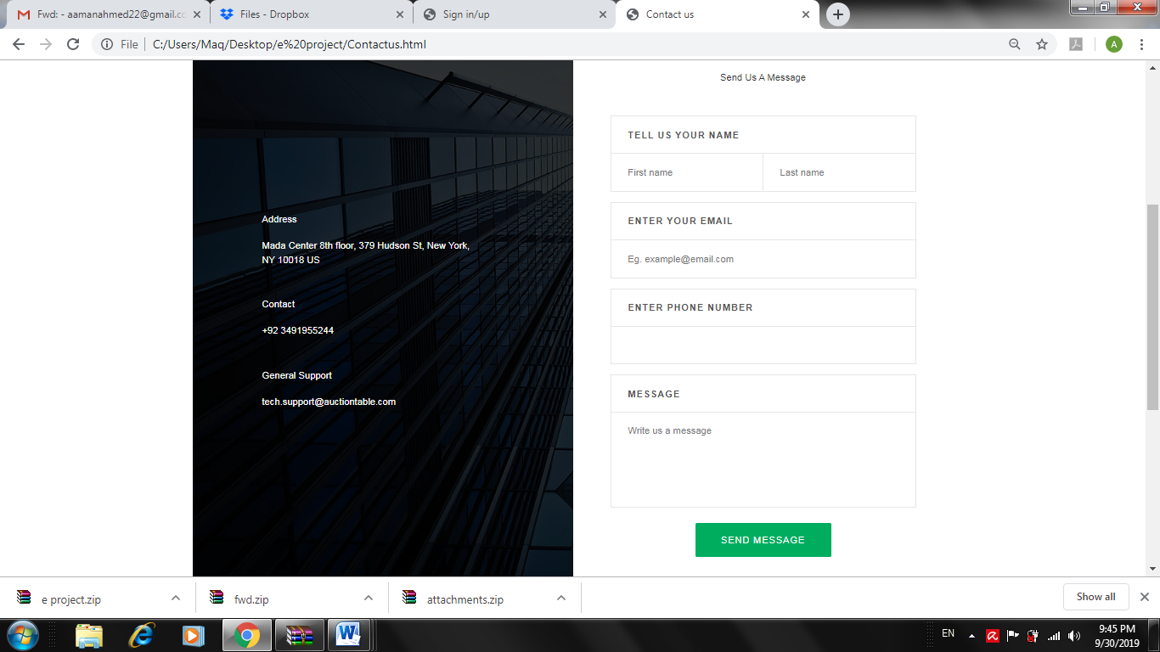

Disclaimer:

